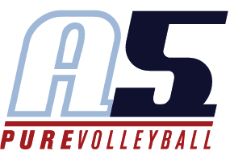
Emily Jensen
Asst. Coach 16-2 Gary

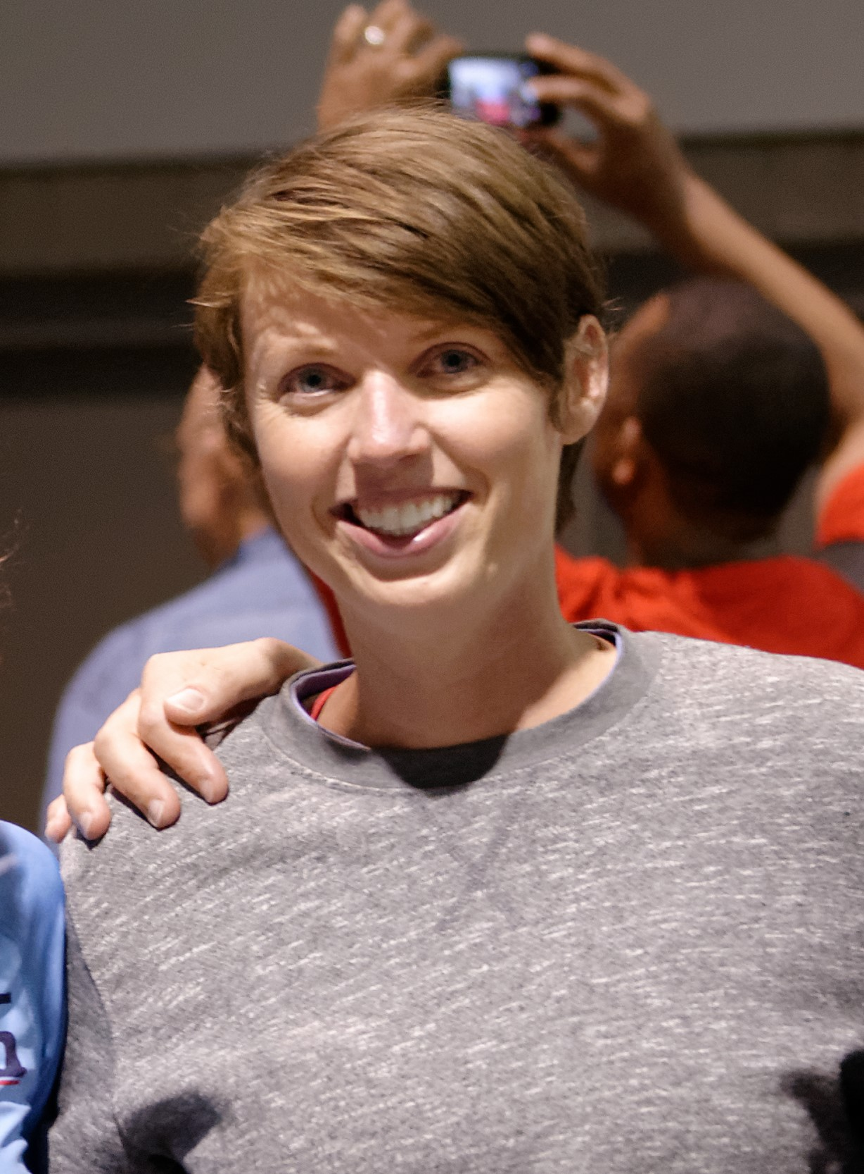
Coaching Experience
2015 – Present
A5 Volleyball
2015 16-2 Gary Asst. Coach
- 5th Place Mideast Qualifier (USA Division)
- 5th Place Disney Qualifier (USA Division)
- 9th Place Big South (USA Division)
- 2015 SRVA Regional Champions

2007 - 2010
A5 Volleyball
2010 17-2 Gary Asst. Coach
- 2nd Place AAU National Championships (Club Division)
- Qualify USAV National Championship (National Division)
- 1st place, Sports Performance President’s Day
- 1st place, A5 Ice Breakers

2009 17-2 Gary Asst. Coach

2008 17-2 Gary Asst. Coach
- 2nd place, Central Zones Invitational
- 2nd place, NASA Big Spring Volleyball Bash

2007 18-3 Eric Asst. Coach
- 1st place, Central Zones Invitational
- 2nd place, President’s Day Cup

Playing Experience
1999 – 2001 Mississippi State Volleyball Team, Right Side
1995 – 1997 Madison Central High School, Girls Varsity Volleyball Team,
1997 – 1998 Jackson Rebels Club Volleyball
Adult Indoor Co-Ed leagues

Education
Mississippi State University, Starkville, Mississippi
- Bachelor of Science, Education, 2002

