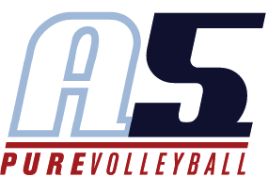
Sydney Hicks
Asst. Coach 14-Lorri (Boys)

Coaching Experience
- Chamblee High School middle school clinics for 4 years

Playing Experience

- 2014: Atlanta Boom 15-1
- 2015: A5 South 17-2
- 2016: A5 South 17-2
- 2013-2016: Varsity Volleyball at Chamblee Charter High School
  - Captain – 2016
Education
- Currently a senior at Chamblee Charter High School

