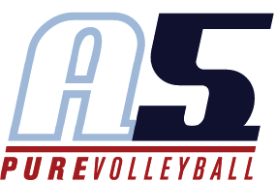
Gary Jensen
Assistant Coach 18-Scott

Coaching Experience
2017-2018 Assistant Coach, A5 Volleyball Club 16-2
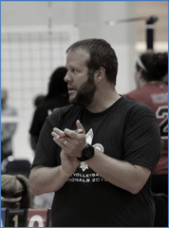
- 2018 USAV National Championship – Gold Medal (16 USA)
- 2018 AAU National Championship – Gold Medal (16 Premier)
- 2018 Big South Qualifier – Gold Medal (16 USA)
- 2018 Bluegrass Tournament – Gold Medal (16 Premier)

2015 – 2017 Co-Head Coach, A5 Volleyball Club 16-2
- 2017 USAV Nationals – National Division
- 2017 SRVA Regional Runner-Up (American Bid)
- 2016 USAV Nationals 5th Place – National Division
- 2016 SRVA Regional Champions (National Bid)
- 2016 Big South Qualifier – Bronze Medal (USA Division)

2011 - 2012 Head Coach, A5 Volleyball Club 17-1 Gary
- 5th Place USAV National Championships (National Division)
- 5th Place AAU National Championships (Open Division)
- 2012 SRVA Regional Champions

2010 - 2011 Floating Assistant Coach, A5 Volleyball Club
- 12-1 Suzanne
- 17-2 Rob - Head Coach for AAU and USAV National Tournaments

2009 - 2010 Head Coach, A5 Volleyball Club 17-2 Gary
- 2nd Place AAU National Championships (Club Division)
- Qualify USAV National Championship (National Division)
- 1st place, Sports Performance President’s Day
- 1st place, A5 Ice Breakers

2008 - 2009 Head Coach, A5 Volleyball Club 17-2 Gary

2007 - 2008 Associate Head Coach, A5 Volleyball Club 17-2 Gary
- 2nd place, Central Zones Invitational
- 2nd place, NASA Big Spring Volleyball Bash

2006 - 2007 Assistant Coach, A5 Volleyball Club 18-3 Eric
- 1st place, Central Zones Invitational
- 2nd place, President’s Day Cup

2008 - 2014 Fall Youth program coach

Playing Experience
1997 – 2000 Mississippi State Club Volleyball, Setter / Player Coach
1993 – 1996 Coral Springs High School, Boys Varsity Volleyball Team

