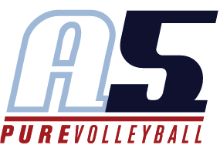
Dominique Washington
Assistant Coach-17 Acevedo

Coaching Experience
2021
Rio Volleyball – Assistant Coach 15’s

Playing Experience

Georgia Institute of Technology- undergrad
- Team Captain (2020 & 2021)
- Brandon Adam’s Award (2021)
- Starting OH/RS (2018)
- ACC Honor Roll (2020)

Florida Agricultural & Mechanical University- grad
- All-American Honorable Mention (2021 & 2022)
- SWAC Championship Title (2021 & 2022)
- SWAC player of the year (2021 & 2022)
- AVCA Southeast All-Region (2021 & 2022)
- SWAC Newcomer of the Year (2021)
- SWAC All-Conference Team (2021 & 2022)
- SWAC Tournament MVP (2021 & 2022)
- All-SWAC First-Team (2021 & 2022)
- Team Captain (2021 &2022)

Club Fusion Volleyball
- 18-1, 17-1

TopFlight Volleyball Club
- 16-1, 15-1, 14-1

Education

Georgia Institute of Technology
- B.S. History, Technology, and Society

Florida Agricultural & Mechanical University
- Master of Business Administration

Other Information

- I currently work for Marsh and McLennan.
- I enjoy traveling and spending time with my three year old yorkipoo , Dior.

