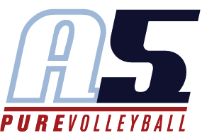
Calvin Kehoe
A5 Assistant Club Director
Head Coach 17-Calvin

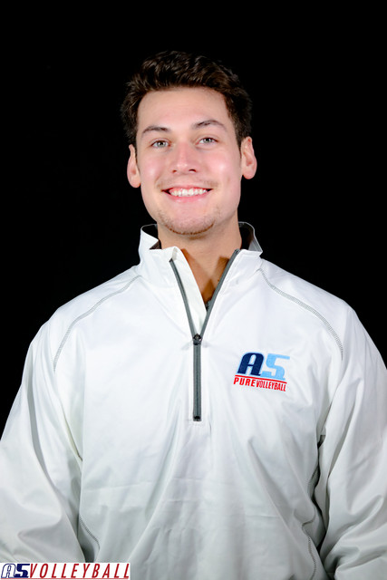
Coaching Experience

A5 Volleyball 20016-2023
- Gold Medalist USAV National Championships 16 Open (2016)
- Gold Medalist AAU National Championships 16 Open (2016)
- 3x National Championship Top 5 Finish (AAU and USAV)
- 4x Medalist National qualifier 14 open (2018)
- Gold Medalist Triple Crown National Championships (2017)
- 6x Qualifier Medalist (3x Gold Medalist)
- 3x Single Season Record Qualifier Gold Medalist 16 Open (2017)
- Mentored under Club Director of the year (2021) and Coach of the year (2016) Gabe Aramian

Mississippi State University (SEC)
- Volunteer Assistant Coach
- Responsibilities included training of all positions, Data Volley input and analysis, film breakdown and scouting reports
- Helped build a new culture for Mississippi State University resulting in a NCAA appearance
- Mentored Under 2020 SEC Coach of the Year Julie Darty

Coaches Director for 575 Lakepoint (2022-2023)
- Lead and developed 26 teams at 575 Lakepoint
- Lead all volleyball programing and skill development for 575 Lakepoint
- Coached two teams (16-1 and 17-1)
- Lead the 16-1 national team to finish 20th in the club division at AAU’s

Playing Experience

- Played for A5 2010 – 2014
- Qualified for boys’ nationals at the open level from 2010 – 2014
- First boys’ team to qualify open in Ga
- Played at Erskine College D1/D2 Program from 2014-2016
- Currently rostered on the Georgia VLA Men’s Pro team (ATL Bobcats)
- Had a second-place finish at Adult Nationals in 2022

Education

- Whitewater High School 2014
- Erskine College 2014-2016
- Kennesaw State University 2016- 2018

