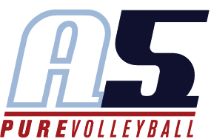
Scott Shelley
Head Coach 18-Scott

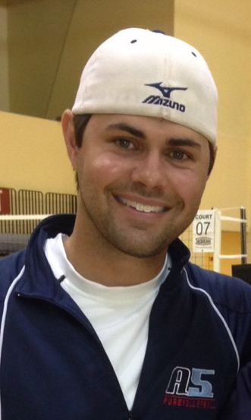
Coaching Experience
2014- 2017 Assistant Coach, Emory University
- 2017 NCAA Division III Final Ranking - #5 (30-7)
- NCAA Regional Champions – Elite Eight
- 2016 NCAA Division III Final Ranking - #2 (33-6)
- NCAA Regional Champions – Elite Eight
- 2014 NCAA Division III National Runner-Up (39-4)
- 2014 & 2016 UAA Champions (Co-Coaching Staff of the Year)
- Current combined record: 136-21

2017-2018 Head Coach, A5 Volleyball Club 16-2
- 2018 USAV National Championship – Gold Medal (16 USA)
- 2018 AAU National Championship – Gold Medal (16 Premier)
- 2018 Big South Qualifier – Gold Medal (16 USA)
- 2018 Bluegrass Tournament – Gold Medal (16 Premier)
- 2018 AVCA Coach of the Year 16 and Under

2015-2017 Co-Head Coach, A5 Volleyball Club 16-2
- 2017 USAV Nationals – National Division
- 2017 SRVA Regional Runner-Up (American Bid)
- 2016 USAV Nationals 5th Place – National Division
- 2016 SRVA Regional Champions (National Bid)
- 2016 Big South Qualifier – Bronze Medal (USA Division)

2012-2015 Assistant Coach, A5 Volleyball Club 18-1
- 2015 Disney Qualifier – Gold Medal (Open Division)
- 2015 Big South Qualifier – Silver Medal (Open Division)
- 2014 USAV National Championships – Bronze Medal (Open Division)
- 2014 Northeast Qualifier – Gold Medal (Open Division)
- 2014 Mid East Qualifier – Silver Medal (Open Division)
- 2014 Big South Qualifier – Bronze Medal (Open Division)

2011- 2012 Assistant Coach, A5 Volleyball Club 17-1
- 5th Place USAV National Championships (National Division)
- 5th Place AAU National Championships (Open Division)
- 2012 SRVA Regional Champions

2010-2011 Assistant Coach, A5 Volleyball Club 17-2
- 3rd Place SRVA Regionals (American Bid)

2009-2010 Co-Head Coach, KC Power Volleyball Club 16-1
- 2010 USAV National Championships – Open Division
- 2010 Lone Star Qualifier – Gold Medal (National Division)
- Heart of America Regional Champions (American Bid)

2004-2009 Assistant Volleyball Coach, Rock Bridge High School, Columbia, Missouri

2004-2009 Assistant Club Director, Club COMO Volleyball Club

