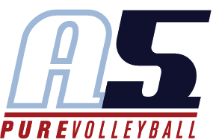
Alexandria Mills
Assistant Coach 18-2 Boba

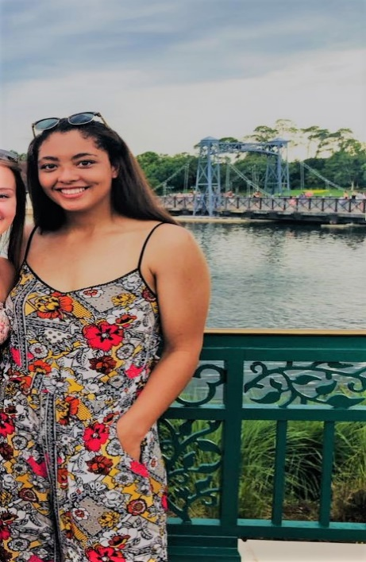

Coaching Experience
- Head Coach for Milton JV Volleyball
- Assistant Coach for 16’3 Liang

Playing Experience

- Played for A5 Volleyball (14’s-18’s)
- Played for Roswell High School (Varsity all four years)
- Reached Elite 8 of state tournament senior year
- Earned AVCA Under Armour Girls High School All-American team honorable mention
- Earned all-state and all area
- Recorded 43 kills in a single match

Education

- Roswell High School
- Towson University
- Georgia State University
- Biology Major

