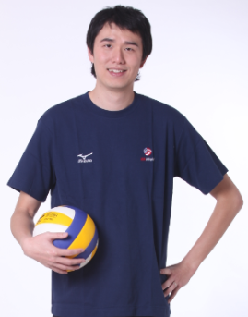
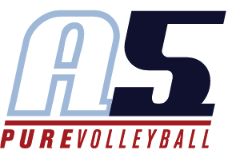
Liang Zhang
Head Coach 16-2

Coaching Experience
2018– A5 16-3 Head Coach
- 2018 SRVA Regional Champion----First “3” team to win Regional Championship
- 2018 AAU National Championship Brown Medal
- 2018 USAV National Division
- 2018 Show Me National Qualifier USA Division 5th place
2017—A5 16-3 Head coach
- Gold Medal Dixie Classic AAU Super Regional----2017
- 5th Big South National Qualifier----2017
- 5th Northeast National Qualifier----2017
2014-2015
Southwestern Community College - Assistant Volleyball Coach and Recruiting Coordinator
2011-2014
Emporia State University - Graduate Assistant
2008-2010
International Budo University (Japan) - Student Assistant

Playing Experience
2006 – 2010
International Budo University
- Elite eight in division one program in 2006 and 2007
- Frenchman of the year in 2006
2003-2006
Saitama State All Star Team
- 2004 Gold Medal Japanese national sports festival
1998 - 2003
Beijing junior men’s volleyball team
- 2001 & 2002 Gold Medal Chinese national junior tournament

Education
Emporia State University
- 2014 - Master Degree in Master of Business Administration
International Budo University (Japan)
- 2010 - Bachelor's Degree in Health, Physical Education

