Demi-Shay Watchorn
Assistant Coach 14-3 Brianna

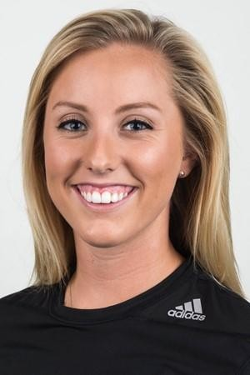

Coaching Experience:
- A5 Volleyball 14-5’s 2017-Current
  - Smoky Mountain Challenge Champions – 14 club
  - Icebreaker Champions – 14 club
  - First Lady Challenge Champion – 14 club
  - Southern Youth Festival Champion – 14 power
- WAVE Alliance Beach Volleyball 2015-2017
  - Constructed and executed practice drills for ages between 12-16
  - Provided higher level volleyball training
  - Developed team strategy and created player partnerships
- Coast Line Beach Volleyball 2014-2015
  - Provided higher level volleyball training

Playing Experience:
- Mercer University Beach Volleyball: 2013-2017
  - Played Division 1 beach volleyball – 4 years
  - Played in 56 matches over four year, helping the Bears' to a program-best 15-12 (7-3 ASUN) season in 2017
  - Defeated nationally-ranked No. 7 Georgia State
  - Helped Mercer finish second in ASUN conference in 2015
- Coast Line Volleyball: 18’s 2012-2013
  - Position - Setter & Captain
- Manatee Area Volleyball: 14s – 17s 2006-2012
  - Position - Setter & Captain
  - Qualified for the Junior Olympics at Northern Lights in 2011.

Braden River High School Varsity Volleyball: 2011-2013
  - Position - Setter & Captain
- Palmetto High School Varsity Volleyball: 2009–2011
  - Position - Setter & Captain

Education
- Mercer University 2013-2017
  - Bachelor of Arts in Communications
  - Bachelor of Arts in Media Studies

