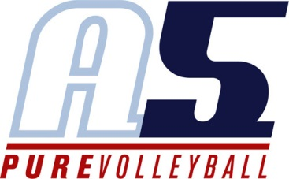
Catelyn Anderson
Assistant Coach 12-2

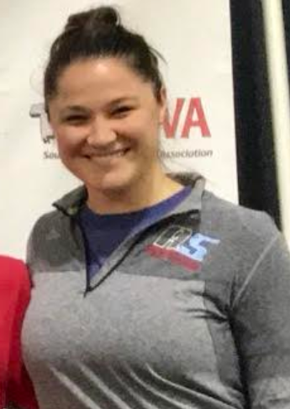
Coaching Experience
A5 12-2 Assistant Coach 2017-2018
- USAV National Tournament
A5 18-2 Assistant Coach 2016-2017
- AAU National Tournament
A5 18-2 Assistant Coach 2015-2016
- USAV National Tournament
- AAU National Tournament
NIVA Volleyball Club (Northern Indiana Volleyball Association)
18’s Travel Head Coach 2013-2014
- Preparing players to move to the collegiate level
- AAU National Tournament
17-2 Travel Co-Coach 2012-2013
- Mix of girls in the 17-18 age group
- AAU National Tournament

Playing Experience
Wheeling Jesuit University 2008-2012 (135-26 record)
NCAA Division II Elite 8 Finish 2011
WVIAC Conference Champions 2008, 2009, 2010, 2011
Sweet Sixteen Appearance 2009, 2011
Atlantic Regional Champions 2011
2007 IHSAA State Runner-Up

