Jenna Seides
11-2 Assistant Coach

Club Volleyball Experience
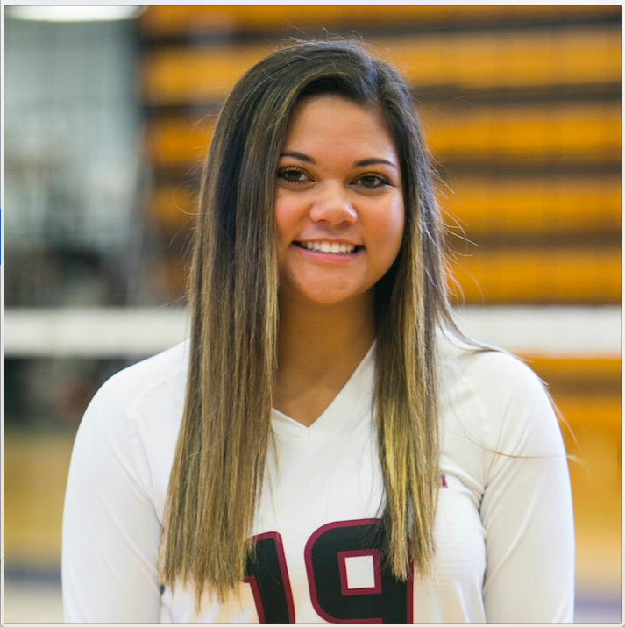
A5 Volleyball (2011-2016)
11-1 Walter (2011-2012)
12-1 Grace (2012-2013)
13-2 Leah (2013-2014)
14-2 Karen (2014-2015)
15-2 JJ (2015-2016)
A5 South Volleyball (2016-2017)
16-1 Joe (2016-2017)

High School Volleyball Experience
Alpharetta High School Varsity Volleyball
(2015-2018)- Libero
- Team Captain 2018
- State Runner Up 2016 and 2017
- 2017 All Area 1st Team
- 2017 AVCA Phenom List
- 2016 AVCA Phenom List
- 2015 AVCA Phenom List

Coaching Experience
- Alpharetta High School Summer Camp (2015-2018)
- Private Coaching (2017-2018)

Personal
I’m a senior at Alpharetta High School this year! Aside from playing volleyball, I enjoy many things. I love traveling the world and spending time with my friends. I enjoy doing mission work and have traveled to Honduras the past 2 summers. I am a part of Girl Scouts and have earned my Bronze, Silver, and Gold Award. I’m also a part of the National Honors Society, National English Honors Society, Beta Club, and other clubs in my school.

