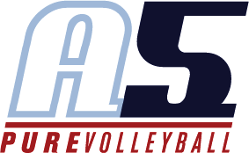
Bob Westbrook
Head Coach 15-1 Bob

Bob Westbrook is a founding member of A5 and continues as one of the primary pillars of the club. His list of accomplishments includes coaching at the NCAA Division I college level for several colleges. He also founded the highly successful Front Range Volleyball Club in Colorado.

Bob has brought national volleyball attention and prominence to Atlanta. His teams have succeeded nationally at the club level and his players continue to have success at the college level. Bob's 2008 18-1 team won the USAV National Division Championship in Dallas and his 2011 18-1 team earned the first-ever 18 Open bid out of the Southern Region. His 2014 18-1 team earned 3 medals at qualifiers and a bronze at USAV Nationals.

Separately from A5, he develops player skills through Volley Performance, an organization he founded and owns.

