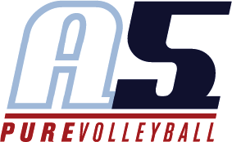
Meg Bright
Assistant Coach18-2

Coaching Experience
2018 Harrison HS Varsity Assistant Coach
2017 A5 13-2 Anna Assistant Coach
2017 Agnes Scott College Assistant Coach 2017 Dunwoody HS Varsity Assistant Coach 2016 A5 14-3 Anna Assistant Coach
2014 Southern Slammers 14-1 Head Coach

2013 A5 South 18-1 Assistant Coach

Playing Experience College

Played Division I Athletics at Air Force and Georgia Southern Division I NCCAA All-American
First-Team All Conference SSAC

Newcomer Player of the Year in the SSAC Conference

