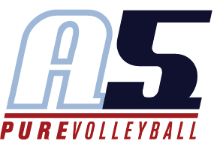
Campbell Morin
Assistant Coach 10-1

Volleyball Experience
-Coached youth camps for Alpharetta volleyball
-Played 3 seasons at Intensity volleyball club
13-1, 14-1, 15-1
Libero
-Received Heart and Soul award on 13-1 team and 15-1 teams
-Played one season at Atlanta Extreme Beach volleyball club
-Played freshman volleyball for Alpharetta High School (2016)
-Won area tournament
-received MVP award
-Played JV volleyball for Alpharetta High School 2017
-Won Area tournament
-Won 2017 Georgia Challenge tournament

